linear regression
-----------------
"Predicts a continuous output value (e.g., house price, temperature) by fitting a straight line (or hyperplane) to the data."
h(x)=hypothesis function
y=h(x)=w0+w1x

y
10| op . *
8 | * *. * up
6 | * .
4 | *. *
2 |.______________x
1 2 3 4 5 6 7 8

--training example(x,y)
--y=h(x)=predicted value
--predicted error=h(x)-y
minimize predicted error using cost function or mean squared error function

op-------over predictions
up-------under prediction

. =dots are best possible line(predicted value)
* =actual value

try to minimize predicted errors (.)

cost function E(W) or or mean squared error
-------------------------------------------

危=summantion

h(x)=h(w)(x(i))=w0+w1x=y

m
E(w)=1/2m 危(h(w)(x(i))-y(i))^2
i=1

--measure of how close the predictions are to the actual y-values
--average over all trainings instances
--mean squared error E(W) cost function

--choose the values w so that E(W) is minimize

w= [w1,w2] = in h(X)=w1+w2x

based w1 and w2 stright line direction and values change

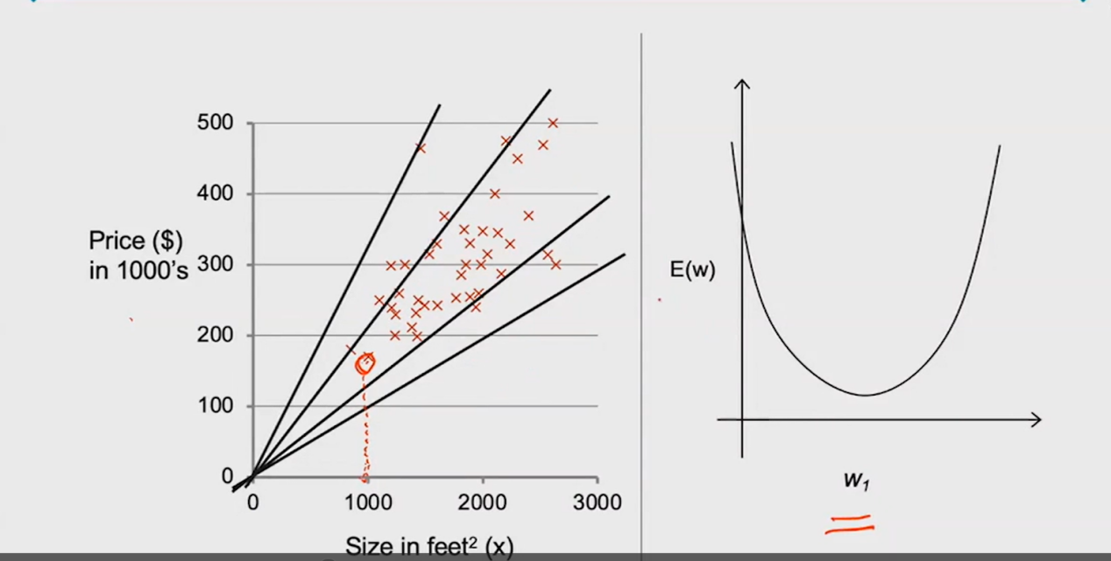

********************************************************
Gradient descent for optimize/minimize the cost function
-------------------------------------------------------------------------------------------
efficent and scalable to thousands of parameters
used in many applications to minimize functions
basic algotitham
start with w , keep changing w little by little to get minimum cost function

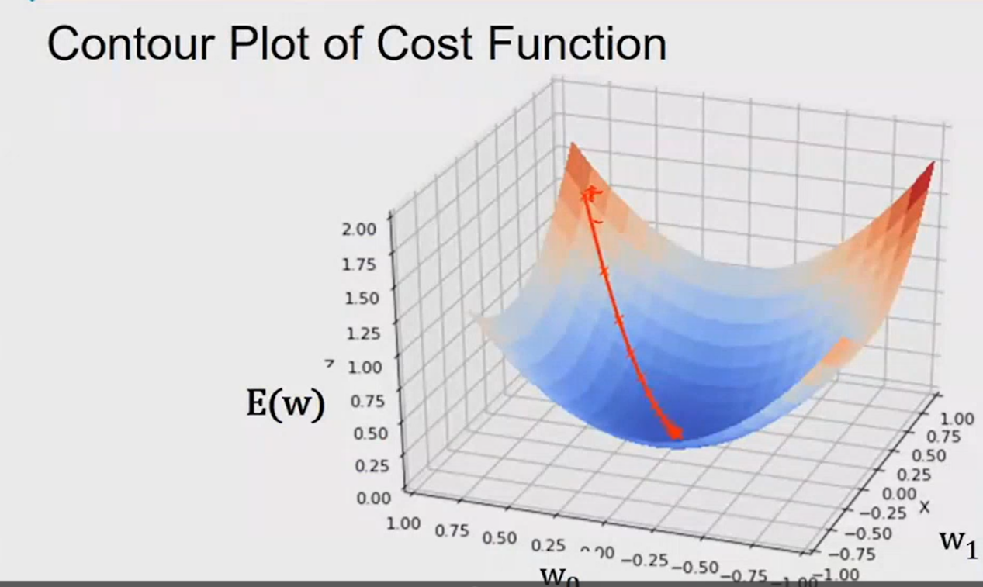

*******************************************************
issues with Gradient descent
---------------------------------------------------------
if we have multiple local minima
it can only find a one local minima not global minima
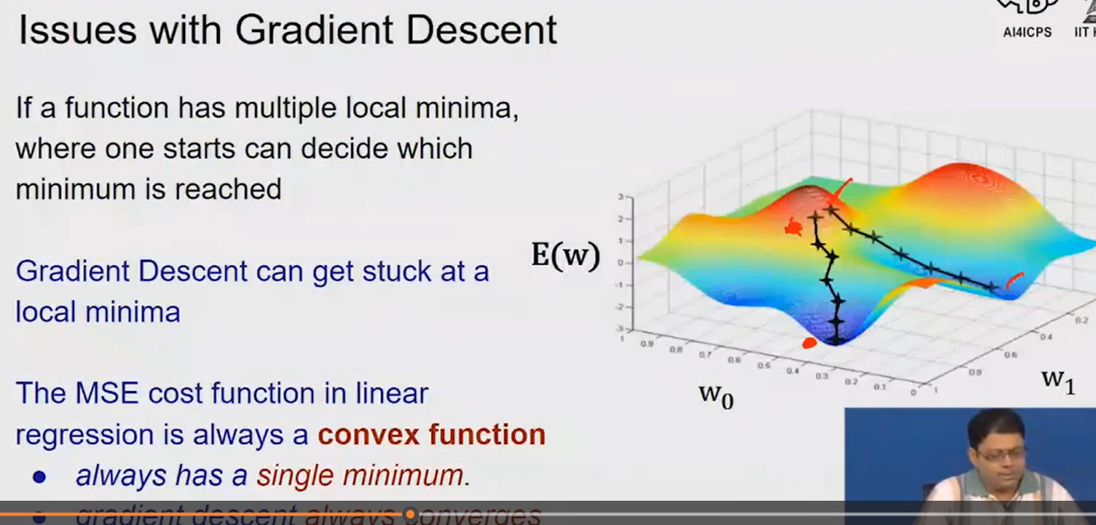

---->but mean squared error cost function in linear regression is always a convex function
so no issue of local minima, it always has a one minima, it always converges to global minima

Gradient descent=w=w-α*(α/αw1)E(w)
α=learning rate

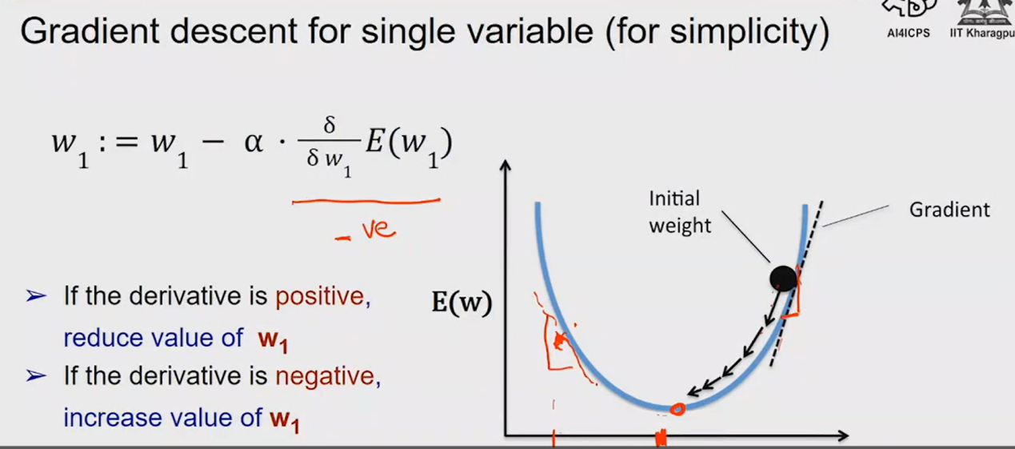

α=learning rate
α should be small enough to converge
α should not be too small to take too long to converge
α should not be too large to overshoot the minima

---------------------------------------------------------
before implementing make sure to feature scaling and mean normalization
normalization is if data is scattered in large range of values make it in small range
normalization formula:
x(i)=(x(i)-mean(x))/range(x)---like statistics
feature scaling is make sure all features are in same range

---------------------------------------------------------
if we have multiple variables/features
h(w)(x)=w0+w1x1+w2x2+...+wnxn, we can for polynomial regression also
Gradient descent for multiple variables, so the curve is non-linear

